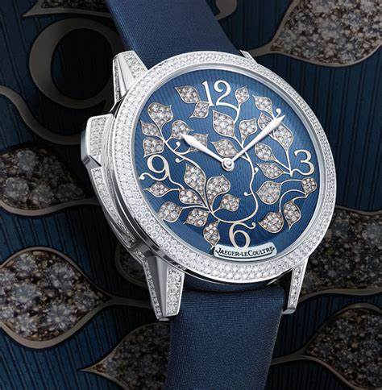Jaeger-LeCoultre

Description: Jaeger-LeCoultre is a brand synonymous with elegance, precision, and horological mastery, offering a refined selection of women's watches that combine timeless design with innovative watchmaking. Known as the "watchmaker’s watchmaker," Jaeger-LeCoultre has crafted movements for some of the most prestigious brands while also producing its own exquisite timepieces.

One of the most iconic collections for women is the **Reverse**, originally designed in 1931 for polo players. Its distinctive **rectangular case** features a reversible mechanism, allowing the watch face to be flipped over, revealing either a personalized engraving, a second time zone, or a different dial design. Available in stainless steel, rose gold, and diamond-set variations, the Reverse is perfect for those who appreciate Art Deco elegance and versatile styling.

For a more delicate and feminine option, the **Rendezvous** collection is a celebration of classic luxury, featuring **round cases, moon phase complications, and intricate guilloche dials**, often adorned with diamonds. Designed for women who appreciate haute horology, the Rendezvous is available in automatic and high-complication models, combining beauty with mechanical excellence.